

**Computer Vision**

**MCA-574**

**Assignment – 01**

***BY***

**HIMANSHU HEDA (24225013)**

**SUBMITTED TO**

**Dr. Preety Shoran**

**SCHOOL OF SCIENCES**

**2024-25**

**Code : --**

# Importing OpenCV library

import cv2

# Load an image from file

image = cv2.imread('pika wallpaper.webp')

output_image_path = 'gray_pika_wallpaper.png'  # Path to save grayscale image

# Check if the image loaded successfully

if image is None:

    print("Error: Could not open or find the image.")

else:

    # Convert the image to grayscale

    gray_image = cv2.cvtColor(image, cv2.COLOR_BGR2GRAY)

    # Save the grayscale image

    cv2.imwrite(output_image_path, gray_image)

    print(f"Grayscale image saved as {output_image_path}")

    # Resize images for better display if too large

    max_width = 800

    scale = 1.0

    if image.shape[1] > max_width:

        scale = max_width / image.shape[1]

        image_resized = cv2.resize(image, (int(image.shape[1]*scale), int(image.shape[0]*scale)))

        gray_resized = cv2.resize(gray_image, (int(gray_image.shape[1]*scale), int(gray_image.shape[0]*scale)))

    else:

        image_resized = image

        gray_resized = gray_image

    # Display the original and grayscale images (resized)

    cv2.imshow('Original Image (Resized)', image_resized)

    cv2.imshow('Grayscale Image (Resized)', gray_resized)

    # Wait indefinitely for a key press

    cv2.waitKey(0)

    # Destroy all windows after key press

    cv2.destroyAllWindows()

**Output :**

**Original Image :**

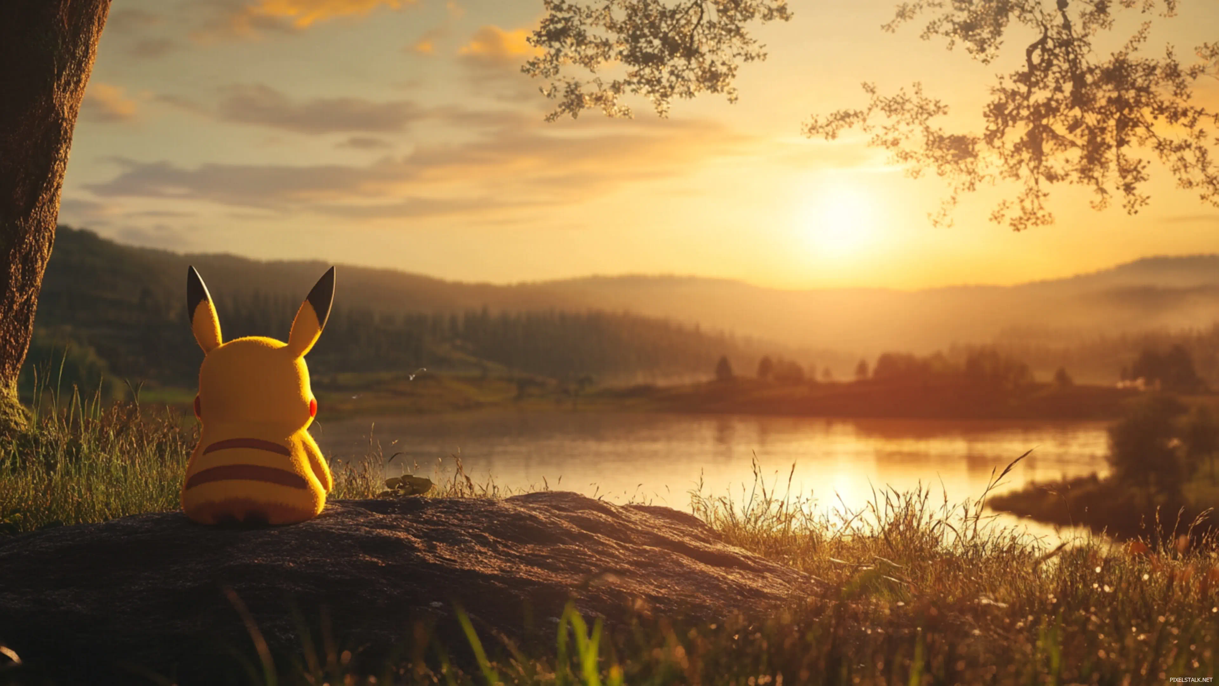

**Gray Scale Image :**

